# Purpose

This document describes how to analyze LFA images taken by the Hamilton STAR liquid handling robot.

# Scope

This document applies to large batch LFA image data, generated from the Hamilton STAR system. Often multiple robot runs are analyzed at a time, and this software is built to enable batch processing. The software can be modified to analyzed lines or spots, to look in either the red, green, blue, or gray color space, and to work with either dark or light background LFAs.

# Definitions

|  |  |
| --- | --- |
| **TERM** | **DEFINITION** |
| PPE | Personal Protective Equipment |
| LFA | Lateral Flow Assay |
| RDT | Rapid Diagnostic Test |

# Related Documents

1. DROP SOP-001: Hamilton STAR Operation
2. DROP Protocol-001: Making and preparing an LFA worklist

# Roles and Responsibilities

|  |  |
| --- | --- |
| **Role** | **Responsibility** |
| Principal User | * Establish and implement this procedure * Ensure users are adequately trained in use of this instrument * Complete Training Form and provide to Quality Manager for recordkeeping * Review procedure periodically for necessary updates |
| Instrument User | * Complete training on use of the instrument * Perform tasks as specified in procedure |
| Lab Manager | * Review procedure periodically for necessary updates |

# Software required to operate code

## To operate the LFA image analysis code, Python and Jupyter notebook are required. Instructions on how to install Jupyter notebook on a Windows machine can be found here - https://www.geeksforgeeks.org/how-to-install-jupyter-notebook-in-windows/

# Files included

## *Jupyter Notebooks:* these are the files that the operator will open to run the analysis code

### Batch_files_and_run.ipynb

## *Python file(s):* Python files that the Jupyter notebook refers to in order to analyze data. Some additional functions are present in these files beyond what is included in the Jupyter notebook file and can be updated if desired.

### backend.py

### generate_batch_files_and_run.py

### Hamilton_image_analysis.py

# Code Variations and Modifications

The LFA Image Analysis code was designed to be flexible for various LFA and RDT formats. The parameters that are required are included below. Adjustments to the code will be supported by GH Labs. If there are any options not included in the list below, contact [caitlin.anderson@ghlabs.org](mailto:caitlin.anderson@ghlabs.org).

**Required parameters:**

* Region to be analyzed (spot or line)
* Color channel (red, green, blue, or gray)
* If lines, number of lines to be analyzed
* Read window size and location
* Background color (light or dark)

# Analyzing LFA Images

## Load analysis code into a new folder.

## The code can be downloaded from: [Analysis software](https://ccampoffice.sharepoint.com/:f:/r/sites/ExternalInDx/Shared%20Documents/C-CAMP_InDx_GHL_Collaboration/Software/Analysis%20software?csf=1&web=1&e=9QzSAP)

*Location: External InDx > C-CAMP_InDx_GHL_Collaboration > Software > Analysis software*

## Save the images taken by the Hamilton STAR into your analysis folder made in 10.2.

## Launch the Jupyter Notebook and navigate to your analysis folder.

## Open the Notebook:

### A new tab will open in your default web browser showing the Jupyter Notebook interface.

### Navigate to the directory where the Jupyter Notebook file is located.

### *Notebook options are Single Plate Analyzer, Batch Plate Analyzer, and Partial Plate Analyzer. More information about each of these can be found in section 12.*

### Select the relevant .ipynb file.

**Figure 1.** Example of Notebook view for the LFA Image Analysis software.

## Run each Kernel:

### Run one Kernel at a time by selecting the Kernel and pressing Shift + Enter or by selecting the “Run” button on the toolbar.

### When a Kernel is running, a [*] will appear next to “In” on the left-hand side. Once it is complete there will be a number that appears inside the brackets.

*Note: Make sure to run the Kernels in order. The analysis will not complete successfully if they are run out of order.*

## **Review Output**: In the analysis folder, the following files will be generated

### In the analysis folder, the following files will be generated:

### Individual CSV file with all batched folders combined titled all_results.csv.

* A batch file for every folder of images that is analyzed. Naming will be “Folder name”.bat

### In the folder of images, the following files will be generated:

* Image.csv – analysis of the images in that folder
* Image_ROI_line.pdf – PDF containing (1) a cropped image of each LFA that was analyzed with (2) the corresponding signal intensity plots for the lines analyzed.

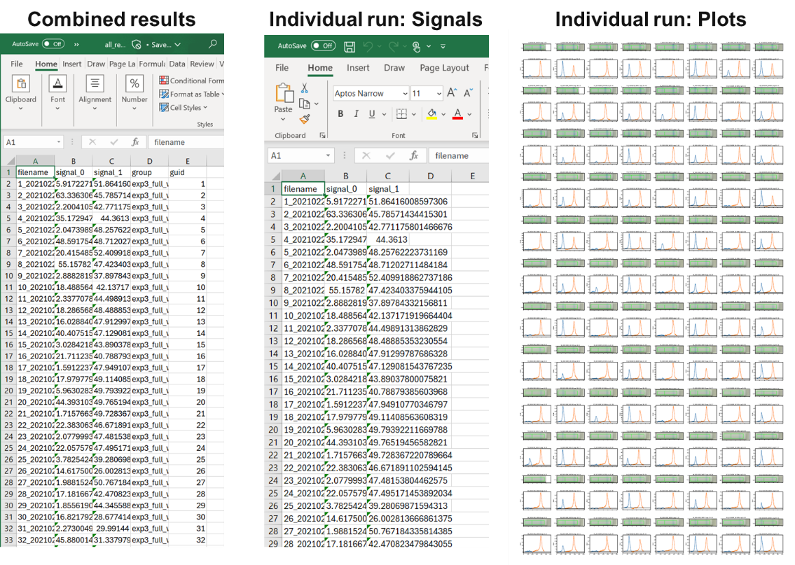

**Figure 2.** Example images of files generated by the Jupyter Notebook. The files are (1) combined results across all folders analyzed (2) individual results for every image in a single folder analyzed in the image folder and (2) individual cropped images and plots for every image in a single folder analyzed in the image folder.

## Generate data report

* .csv file data may be reported as S/N or S-N indices to compare performance across different conditions tested.
* .pdf file data may be manually cropped to include in reports and/or presentations.

## Save Your Work:

### Remember to save your work frequently by clicking the save icon or pressing Ctrl + S.

## Shut Down the Notebook:

### When you’re done, you can shut down the notebook by closing the browser tab and stopping the Jupyter server in your terminal by pressing Ctrl + C.

# Image Processing

High level description of the process carried out by the LFA Image Analysis code. This is completed for every single image in the folder(s) that is/are being analyzed.

* + 1. **Load image:** Loads the image (.png) taken by the robot.

**Figure 3.** Example image produced by the Hamilton STAR robot.

* + 1. **Simple crop:** Simple crop as defined by input image processing parameters. The region is roughly identified in yellow in the image below.

**Figure 4.** Example image produced by the Hamilton STAR robot with the region of interest highlighted. This is the region that is selected for the first crop.

* + 1. **Second crop:** Uses line identification to narrow the analysis window to just the read window on the RDT cassette. The area that will be analyzed is in the middle section of the cassette, as highlighted in green below. This avoids any interference due to uneven lighting and shadows that may occur for some RDTs.

**Figure 5.** Cropped image produced by the Hamilton STAR robot with the region of interest for signal analysis highlighted. This is the region that is selected for the second crop.

* + 1. **Quantify:** Determines intensity of signal at the test and control lines by using measuring the mean intensity along each column in the image. Line detrend can be used to flatten the curve and account for uneven lighting.

**Figure 6.** Example of a signal intensity plot that is produced for every strip that is analyzed by this code.

# Records

This SOP does not generate any records.

# Document Revision History

|  |  |  |  |  |
| --- | --- | --- | --- | --- |
| **REV.#** | **DATE** | **AFFECTED SECTNS.** | **CHANGE DESCRIPTION** | **AUTHOR/OWNER** |
| 00 | 01 July 2022 | N/A | (Initial Release) | Caitlin Anderson and Luis Alonzo |
| 01 | 22 October 2024 | 8 | Updated information around code options | Caitlin Anderson |
|  |  |  |  |  |
|  |  |  |  |  |

Only the four most recent revisions are listed.

*<EOF>*